- Hayami Amamiya
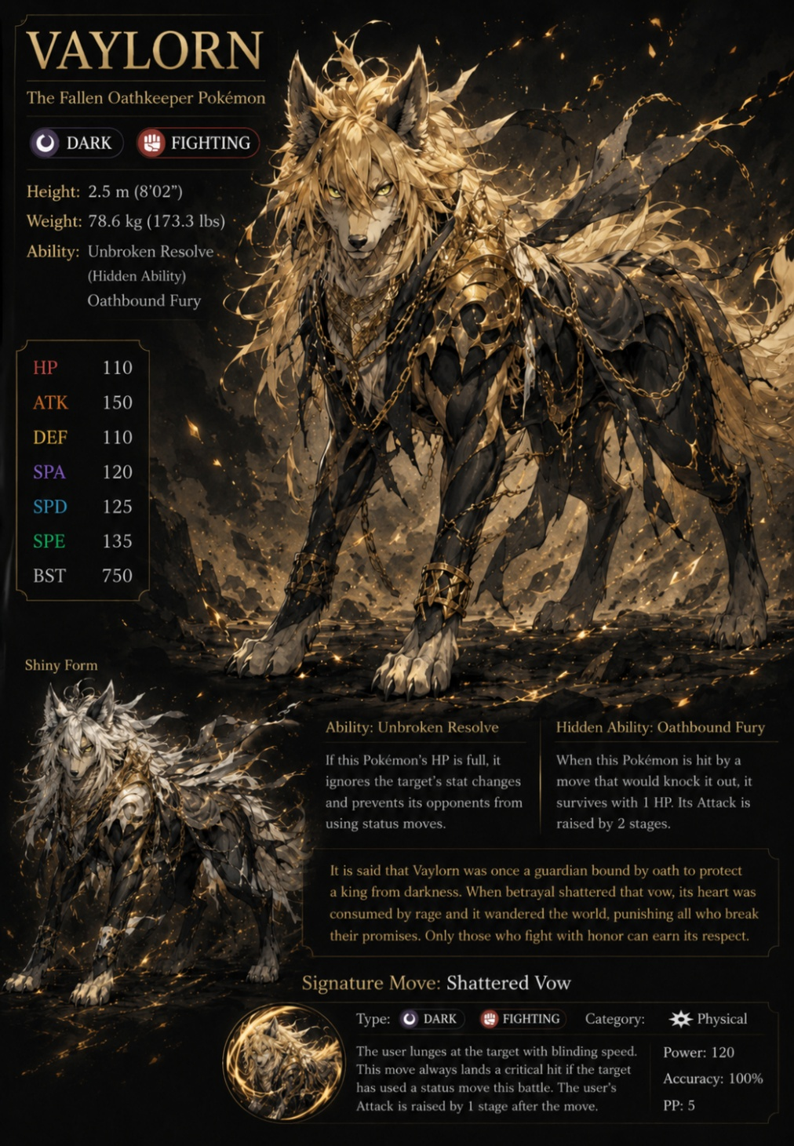
- Base Animal (Chill Mode) : Normal Wolf
- Beast Deity (Engange Mode) : Vaylorn – The Fallen Oathkeeper
- Height : 2.5 m (8’02”)
- Weight : 78.6 kg (173.3 lbs)
- Element : Dark & Fighting

“It is said that Vaylorn was once a guardian bound oath to protect a king from darkness. When betrayal shattered that vow, its heart was consumed by rage and it wndered the world, punishing all who break their promises. Only those who fight with honor can earn its respect.”

A massive, powerfully built lupine guardian standing at 2.5 meters tall, blending fierce, predatory wolf features with an almost human-like intelligence in its posture. It possesses a sleek, midnight-black coat on its chassis, heavily contrasted by an explosive, wild mane of golden-blonde fur that cascades down its neck, back, and head, mimicking wild hair. It is adorned with ornate, dark-gold filigree armor plating around its chest, neck, and forelegs. Entwined throughout its mane and draped loosely over its body are heavy, glowing golden chains that trail off behind it like shattered bonds. Sharp, piercing golden-yellow eyes that gleam with a cold, unforgiving intensity.

- Core Ability : Unbroken Resolve – If HP is full, Vaylorn ignores the target’s stat changes and prevents opponents from using status moves.
- Hidden Ability : Oathbound Fury – When hit by a move that would knock it out, Vaylorn survives with 1 HP and Vaylorn’s attack is raised sharply (2 stage)
- Signature Move : Shattered Vow – Vaylorn lunges at the target with bounding speed. This move always lands a critical hit if the target has used a status move in battle. Vaylorn’s attack is raised after the move (1 stage)
- Additional Moves :
- Oathkeeper's Roar - Vaylorn lets out a deafening roar of void beam that lowers the target's Attack and Special Attack by 1 stage each if the target’s not knockdown after hit by the beam. The beam also lowers the target’s resolve.
- Shadow Fang - Vaylorn's fangs become cloaked in shadow as it strikes. Has a 30% chance to cause the target to flinch.
- Revenge Strike - Vaylorn channels its rage into a powerful counter. Power doubles if Vaylorn was hit by the target on the battlefield.
- Oathbreaker's Bane - Vaylorn punishes those who rely on cheap tactics. Deals double damage against targets that have had their stats raised during the battle.
- Iron Will - Vaylorn steels its resolve, bracing for impact. Raises Vaylorn's Defense and Special Defense by 2 stages and prevents flinching in battle.
- Warden's Judgment - Vaylorn delivers a swift, punishing strike. This move ignores the target's Defense stat boosts and deals damage based on raw stats.

HP | 110
Attack | 150
Defense | 110
Special Attack | 145
Special Defense | 125
Speed | 140
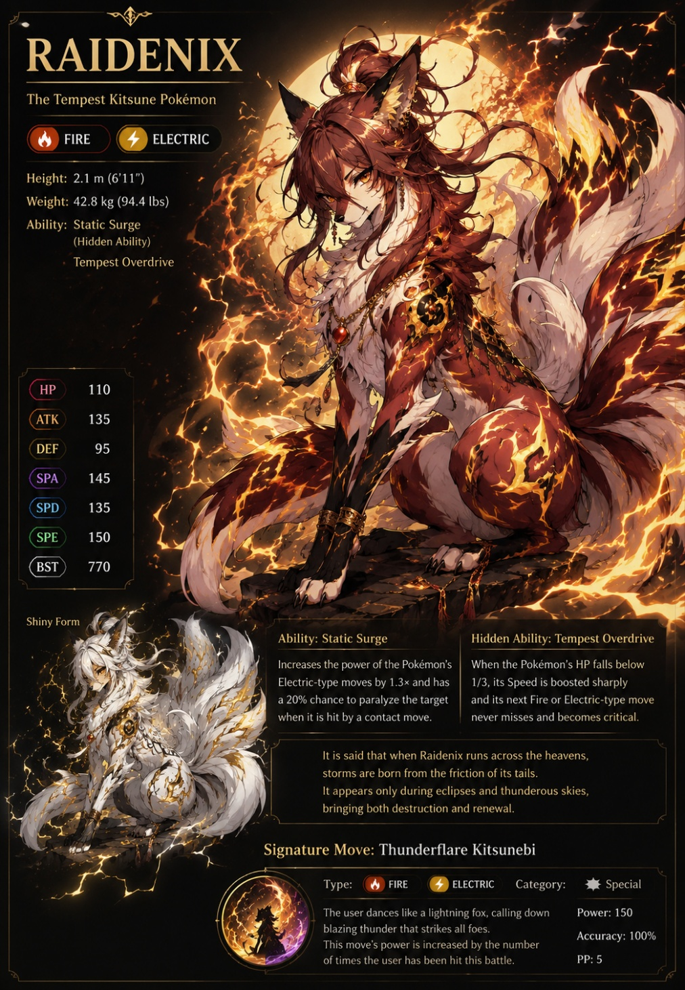
- Aria “Aya” Typhoon
- Base Animal (Chill Mode) : Normal Fox
- Beast Deity (Engange Mode) : Raidenix – The Tempest Kitsune
- Height : 2.1 m (6’11”)
- Weight : 42.8 kg (94.4 lbs)
- Element : Dark & Fighting

“It is said that when Raidenix runs across the heavens, storms are born from the friction of its tails. It appears only during eclipses and thunderous skies, bringing both destruction and renewal.”

A majestic, multi-tailed kitsune fox standing at 2.1 meters, built with an incredibly agile, slender, and aerodynamic frame designed for extreme speed. Covered in a rich, burnt-crimson and auburn coat, featuring stark white fur across its underbelly, chest, and inner ears. Its crowning feature is a massive, multi-layered crest of fiery auburn hair tied up neatly at the top of its head, spilling down its back. It boasts a fan of large, voluminous, flame-like tails that appear to be made of pure, billowing heat. The entire body is constantly enveloped in crackling, gold-colored lightning arcs that dance between its paws and along its markings. Subtle black and gold bracers clip onto its forelegs, and a dark crimson orb talisman hangs from an intricate gold chain around its neck.

- Core Ability : Static Surge – Increases the power of Electric-type moves by 1.3x and has a 20% chance to paralyze the target when it is hit by a contact move
- Hidden Ability : Tempest Overdrive – When Raidenix’s HP falls below 1/3, its speed is boosted sharply and its nect Fire or Electric-type move never misses and becomes critical.
- Signature Move : Thunderflame Kitsunebi – Raidenix dances like a lightning fox, calling down blazing thunder that strikes all foes. This move’s power is increased by the number of time Raidenix has been hit this battle.
- Additional Moves :
- Static Cloak - Raidenix surrounds itself with a crackling barrier of static electricity. For 3 turns, any opponent that makes contact with Raidenix becomes paralyzed (30% chance).
- Flame Dash - Raidenix becomes a blur of fire and lightning as it charges the target. This move has a 20% chance to burn the target.
- Tempest Tail - Raidenix lashes out with all its tails, each one crackling with thunder. Deals damage and has a 30% chance to lower the target's Speed by 1 stage.
- Foxfire Veil - Raidenix conjures a veil of dancing blue flames. Raidenix's evasiveness is raised by 1 stage and it is immune to status moves.
- Thunderclap Burst - Raidenix unleashes a sudden burst of thunder. This move hits all adjacent opponents. Power increases by for each time Raidenix has been hit in battle.
- Crimson Eclipse - Raidenix channels the power of a solar eclipse into a devastating flame attack. This move has a 30% chance to burn the target and leaves a sunspot on the battlefield, boosting Fire-type moves for all allies.

HP | 110
Attack | 135
Defense | 95
Special Attack | 145
Special Defense | 125
Speed | 150

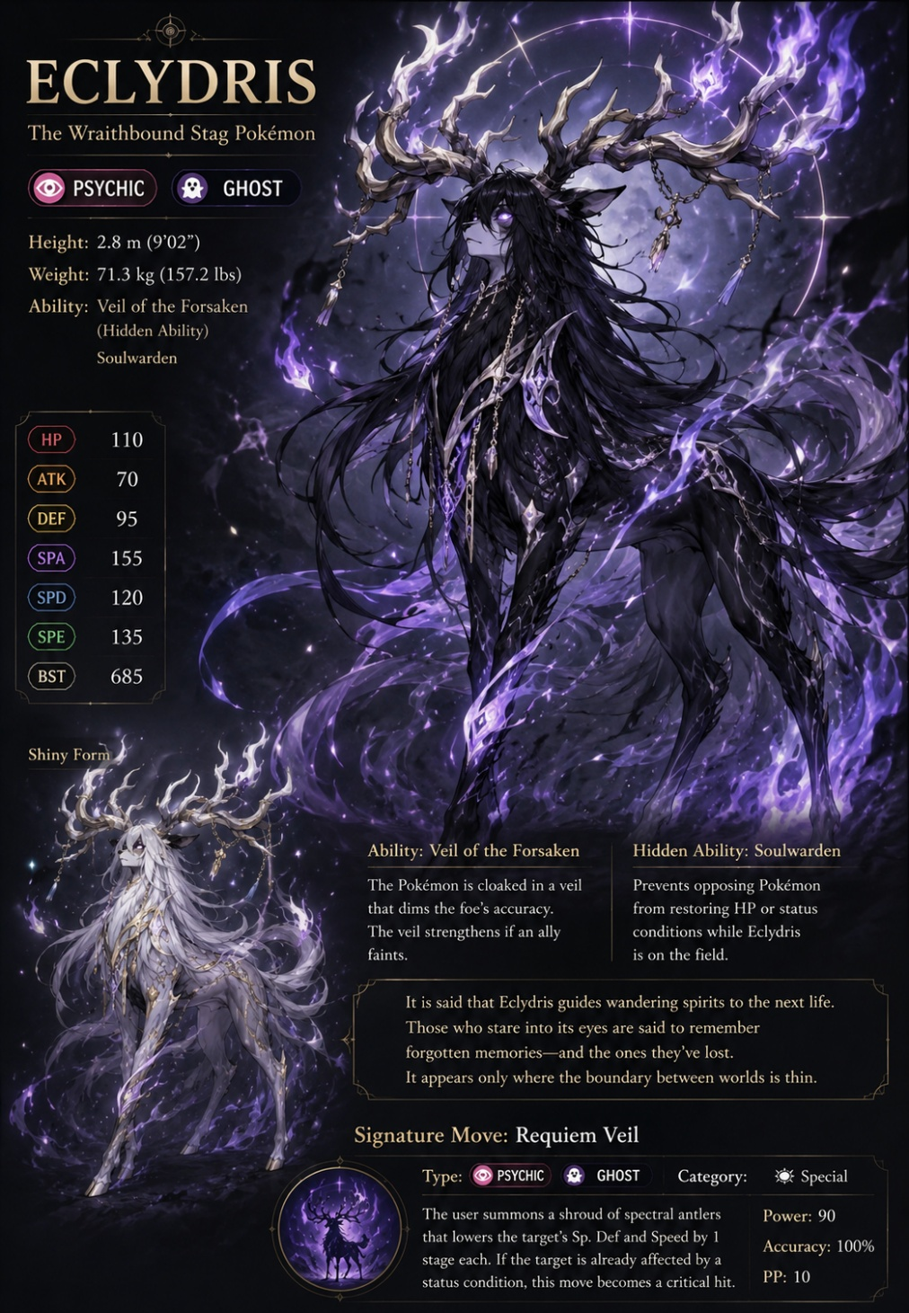
- Rima Rain
- Base Animal (Chill Mode) : Normal Deer
- Beast Deity (Engange Mode) : Eclydris – The Wraithbound Stag
- Height : 2.8 m (9’02”)
- Weight : 71.3 kg (157.2 lbs)
- Element : Psychic & Ghost

“It is said that Eclydris guides wandering spirits to the next life. Those who stare into its eyes are said to remember forgotten memories and the one they lost. It appears only where the boundaries between worlds is thin“

A hauntingly elegant, phantom stag standing 2.8 meters tall, possessing a slender, elongated torso and graceful legs that end in delicate hooves. Its body is swathed in a velvet, pitch-black coat. A massive, flowing mane of long, ink-black hair drapes over its face and down its entire torso like a silken cloak, moving as if floating underwater. Its crowning glory is an enormous, sprawling crown of gnarled, bone-colored antlers that radiate a continuous, billowing shroud of ethereal purple flames. Delicate spiritual crystals and silver jewelry hang loosely from the tines. Completely devoid of pupils; its eyes are solid, glowing spheres of intense violet spiritual energy.

- Core Ability : Veil of the Forsaken – Eclydris is cloaked in a veil that dims the foe’s accuracy. The veil strengthens if ally faints.
- Hidden Ability : Soulwarden – Prevents opponent from restoring HP or status conditions while Eclydris is on the field.
- Signature Move : Requiem Veil – Eclydris summons a shroud od spectral antlers that lowers the target’s Special Defense and Speed by 1 stage each. If the target already affected by a status condition, this move becomes a critical hit.
- Additional Moves :
- Spectral Stare - Eclydris locks eyes with the target, projecting an overwhelming spiritual pressure. Paralyzes the target and lowers their Special Defense by 1 stage.
- Phantom Charge - Eclydris charges forward as a flickering apparition. This move has a 30% chance to confuse the target. Deals double damage if the target is under a status condition.
- Grave Mist - Eclydris releases a chilling mist of spectral energy. This move hits all opponents and has a 40% chance to lower the target's Accuracy by 1 stage.
- Spirit Ward - Eclydris erects a spiritual barrier around itself. Eclydris takes reduced damage from Special attacks and heals 1/16 of its HP each turn.
- Ethereal Stomp - Eclydris stomps the ground, releasing a wave of spiritual energy. This move deals damage and removes any terrain effects on the battlefield.
- Soul Harvest - Eclydris reaps the spiritual energy of its target. If this move knocks out the target, Eclydris recovers 50% of its maximum HP.

HP | 110
Attack | 100
Defense | 100
Special Attack | 160
Special Defense | 120
Speed | 135

- Putri Storm
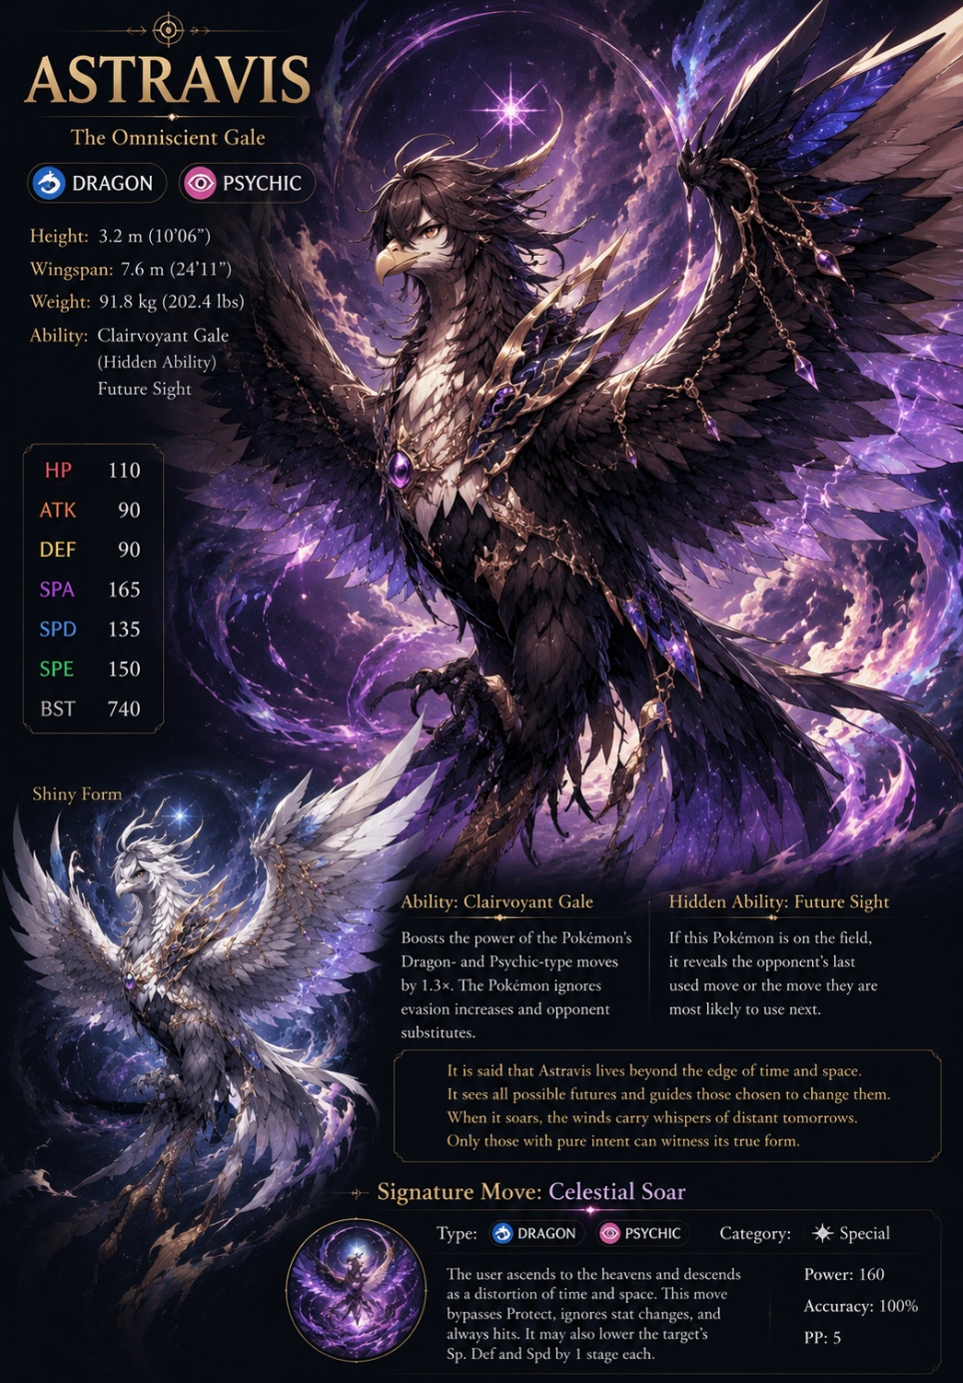
- Base Animal (Chill Mode) : Normal Eagle
- Beast Deity (Engange Mode) : Astravis – The Omniscient Gale
- Height : 3.2 m (10’06”)
- Weight : 91.8 kg (202.4 lbs)
- Element : Dragon & Psychic

“It is said that Astravis lives beyond the edge of time and space. It sees all possible futures and guides those chosen to change them. When Astravis soars, the winds carry whispers of distant tomorrows. Only those with pure intent can witness its true form.”

A colossal, terrifyingly majestic avian deity standing 3.2 meters tall with an imposing 24-foot wingspan, blending the features of a royal eagle with cosmic armor. Dominated by sharp, layered feathers of a dark, midnight-brown and obsidian shade, creating a massive silhouette that blocks out light. Its wings and tail feathers melt seamlessly into swirling, cosmic rifts that shimmer with deep purple galaxies, nebulae, and pinprick stars. A singular, blinding star-like gem floats directly between its pointed crest feathers. It wears royal, sharp-edged gold armor plating across its chest, shoulders, and beak, inlaid with flawless, glowing purple gemstones that drip down on delicate chains.

- Core Ability : Clairvoyant Gale – Boost the power of Dragon and Psychic-Type moves by 1.3x. Astravis ignores evasion increases from opponent.
- Hidden Ability : Future Sight – If Astravis is on the field, it reveals the opponent’s last used move or the move they are most likely to use next.
- Signature Move : Celestial Soar – Astravis ascends to the heavens and descends as a distortion of time and space. This moves always hit. It may also lower the target’s Special Defense and Speed by 1 stage.
- Additional Moves :
- Galactic Wing - Astravis sweeps its cosmic wings toward the target, releasing a wave of celestial energy. Has a 20% chance to lower the target's Defense by 1 stage.
- Future Pulse - Astravis channels its ability to see the future into a precise strike. This move has a 100% accuracy rate and always lands a critical hit if the target has not yet moved this turn.
- Starlight Shroud - Astravis wraps itself in a shroud of starlight, becoming difficult to perceive. Raises Evasion by 1 stage and the next move used by Astravis cannot miss.
- Temporal Roar - Astravis lets out a roar that distorts time itself. Deals damage and has a 20% chance to flinch the target. If the target's Speed is higher than Astravis, this move deals 1.3x damage.
- Celestial Shield - Astravis summons a barrier of cosmic light. Astravis and its allies take reduced damage from all attacks and are immune to critical hits.
- Event Horizon - Astravis tears open a rift in space, dragging the target into a vortex of cosmic energy. This move lowers the target's Special Defense by 1 stage after dealing damage. If used on the same target twice in a row, the second hit deals 1.3x damage.

HP | 110
Attack | 90
Defense | 90
Special Attack | 165
Special Defense | 135
Speed | 150

- Valeria “Val” Bolt
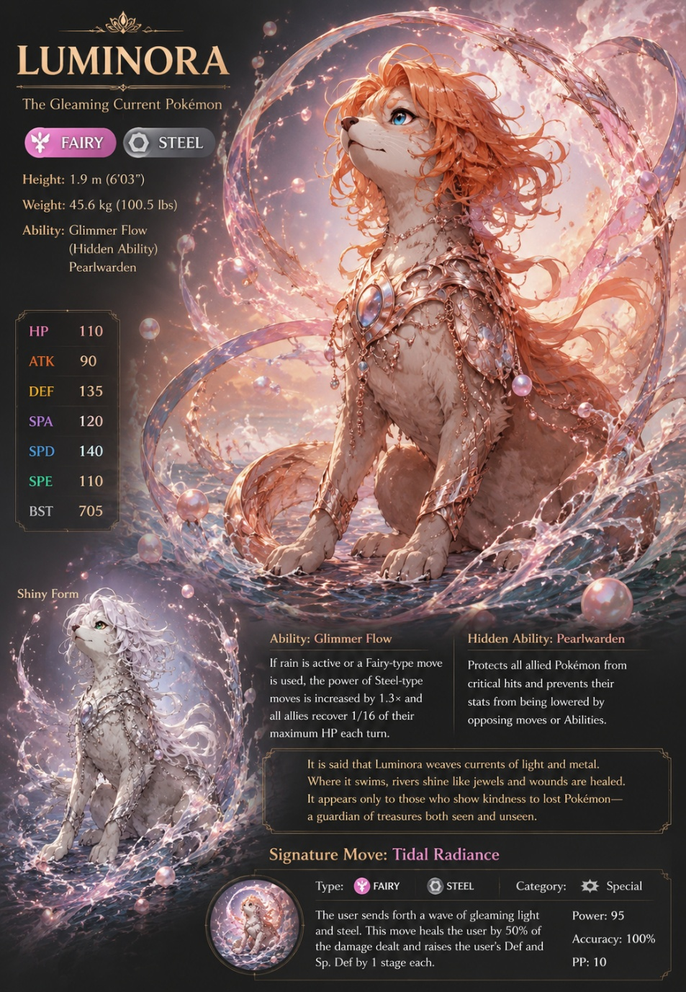
- Base Animal (Chill Mode) : Normal Otter
- Beast Deity (Engange Mode) : Luminora – The Gleaming Current
- Height : 1.9 m (6’03”)
- Weight : 45.6 kg (100.5 lbs)
- Element : Fairy & Steel

“It is said that Luminora weaves currents of light and metal. Where it swims, rivers shine like jewels and wounds are healed. It appears only to those who show kindness, a guardian of treasures both seen and unseen.”

A sleek, regal, and exceptionally graceful mammalian beast standing at 1.9 meters tall, sharing a streamlined body line with an otter or a sea lion, built to glide effortlessly through elements. Features a smooth, pristine cream-colored coat with a soft tan undertone. It sports a crown of wavy, fluid, peach-orange hair that flows around its head and down its spine like liquid currents. Adorned in beautifully sculpted, rose-gold filigree armor that fits like a second skin around its neck, shoulders, and forelegs. Floating, shimmering pink pearls and orbs of pressurized water continuously orbit its body. Large, soulful, and brilliant crystal-blue eyes.

- Core Ability : Glimmer Flow – If rain it’s raining or a Fairy-type move is used, the power of Steel-type moves is increased by 1.3x and all allies recover 1/16 of their maximum HP each turn.
- Hidden Ability : Pearlwardeen – Protects all allies from critical hits and prevents their stats from being lowered by opposing moves or abilities.
- Signature Move : Tidal Radiance – Luminora send a wave of gleaming light and steel. This move heals Luminora by 50% of the damage dealt and raises its own Defense and Special Defense by 1 stage.
- Additional Moves :
- Gleaming Strike - Luminora charges forward with a radiant strike. Has a 30% chance to raise Luminora's Defense by 1 stage.
- Ripple Veil - Luminora creates a shimmering veil of water and light around itself. Luminora and its allies heal 1/16 of their maximum HP each turn and are immune to status conditions.
- Pearl Missile - Luminora fires a concentrated blast of gleaming pearl energy. This move has a 30% chance to lower the target's Special Defense by 1 stage.
- Tidal Embrace - Luminora calls forth a wave of gentle healing energy. Restores 50% of Luminora's maximum HP and removes all status conditions from itself.
- Moonlight Stream - Luminora releases a flowing stream of liquid moonlight. This move heals Luminora by 25% of the damage dealt and has a 20% chance to lower the target's Accuracy by 1 stage.
- Aqua Radiance - Luminora unleashes a devastating wave of radiant water energy. This move deals damage and has a 30% chance to burn the target. If it is raining, this move never misses and power increases by 1.3x.

HP | 110
Attack | 100
Defense | 140
Special Attack | 120
Special Defense | 150
Speed | 110

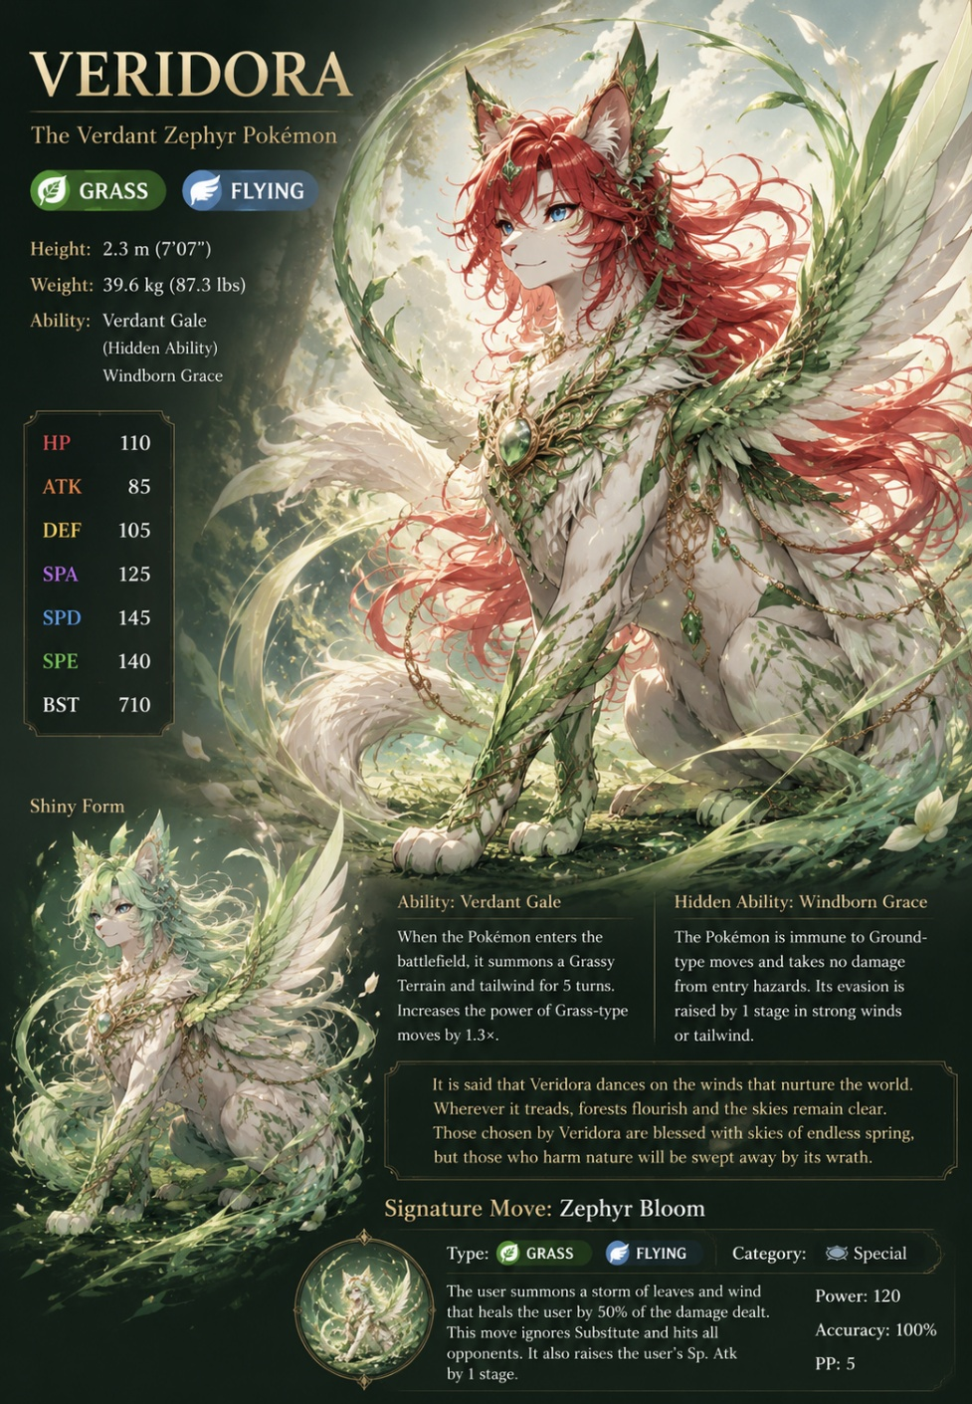
- Tulip Karasu
- Base Animal (Chill Mode) : Normal Cat
- Beast Deity (Engange Mode) : Veridora – The Verdant Zephyr
- Height : 2.3 m (7’07”)
- Weight : 39.6 kg (87.3 lbs)
- Element : Grass & Flying

“It is said that Veridora dances on the winds that nurture the world. Wherever it treads, forest flourish and the skies remain clear. Those chosen by Veridora are blessed with skies of endless spring, but those who harm nature will be swept away by its wrath.“

A striking, mythical winged feline standing 2.3 meters tall, carrying the fierce elegance of a great cat crossed with a forest spirit. Its primary coat is a soft, marbled ivory white, but it is dramatically offset by a brilliant, flowing mane of long, vivid crimson hair that billows outward like autumn leaves in a storm. Its legs, tail, and face are patterned with living, leafy green vines and emerald jewelry woven directly into its fur. It possesses a magnificent pair of feathered wings that are a gradient of soft cream, emerald green, and leaf textures. Striking, playful, and sharp sky-blue eyes.

- Core Ability : Verdant Gale – When Veridora enters the battlefield, it summons a Grassy Terrain and tailwind for 10 minutes. Increases the power of Grass-type moves by 1.3x.
- Hidden Ability : Windborn Grace – Veridora is immune from hazards. Its evasion is raised by 1 stage in strong winds or tailwind.
- Signature Move : Zephyr Bloom – Summons a storm of leaves and wind that heals Velidora by 50% of the damage dealt. This move ignores hits from opponent. It also raises Velidora Special Attack by 1 stage.
- Additional Moves :
- Wind Cutter - Veridora summons sharp blades of wind to slice the target. This move has a 30% chance to lower the target's Accuracy by 1 stage and always hits opponents in the air.
- Vine Trap - Veridora ensnares the target in living vines. This move deals damage and prevents the target from fleeing.
- Nature's Grace - Veridora draws power from the land itself. Restores 25% of Veridora's maximum HP and removes any stat drops caused by the opponent.
- Whirlwind Dash - Veridora becomes a blur of wind and leaves as it strikes. This move has a 20% chance to flinch the target.
- Verdant Storm - Veridora summons a swirling storm of razor-sharp leaves. This move hits all adjacent opponents. If Grassy Terrain is active, power increases by 1.3x and Veridora recovers 1/16 of its HP.
- Zephyr Ascension - Veridora rises high into the air, carried by powerful winds. Veridora's Speed is raised by 2 stages and it becomes immune to Ground-type moves. The next move used by Veridora will have increased Speed.

HP | 110
Attack | 100
Defense | 105
Special Attack | 125
Special Defense | 145
Speed | 145

